

**CPD Event – Wednesday 20th May 2015**

**Attachment, Survival and Human Relationships**

With **Mandy Squires and Gillian Downie**

Attachment, Survival and Human Relationships

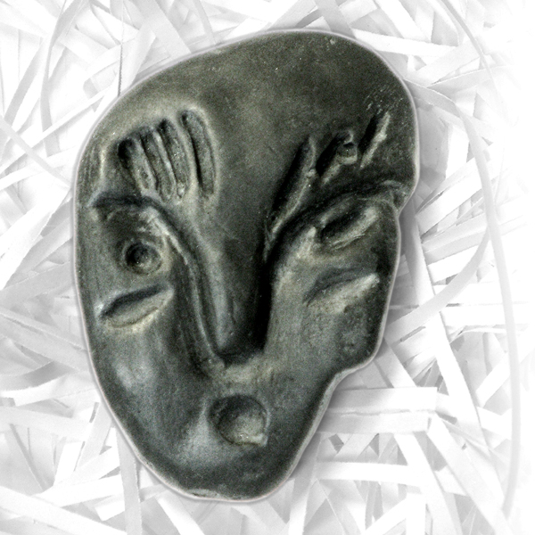

This workshop will use imagination and embodiment to explore themes pertinent to attachment theory and how early relationships impact on our sense of self and connection to others.

We will use play, story, drama, movement, sound and enactment within a safe and holding space to creatively explore attachment and issues of abandonment, neglect and abuse. Your curiosity is invited to discover what the themes mean for you personally and professionally.

This workshop will be relevant for those professionals who work with children, and those who work with adults exploring their inner child.

# Mandy is a member of the British Association of Counsellors and Psychotherapists (BACP), British Association of Social Workers (BASW), The Sesame Institute (Drama and Movement in Therapy) and is registered with the Care Council for Wales. A curiosity in growth and development through play and embodied imagination led Mandy towards experiential creative arts therapies training 15 years ago, which continues to play a major role in her current practice and professional development. **As well as providing a safe, holding container for the exploration of difficult and painful issues and emotions, Mandy aims to promote playfulness, vitality and a sense of hope within the therapeutic space.** She has a passion for storytelling and song, and regularly performs in Wales.

**Gillian** is a HCPC registered Dramatherapist, creative arts supervisor and Gestalt psychotherapist (UKCP reg). She has tutored on the Psyche and Soma training and the WPP Gestalt psychotherapy training in Wales. She regularly facilitates continual professional development days with the Sesame Institute. Gillian works as a therapist for the NHS as well as in private practice. She plays the clarinet and is a member of The Golden Thread Playback Theatre Company.

Gillian and Mandy have worked together for 10 years, and love sharing their passion for stories and embodiment.

**This training counts as 6 hours towards CPD.**

**DATE** Wednesday 20th May 2015

**VENUE**  Gestalt Centre Wales, 10 Hocker Hill Street, Chepstow, NP16 5ER

**TIMINGS**  Arrive from 09.30 for a 10.00 prompt start, finishing at 4.30pm

**COST** £55.00 (early bird fee) if booked by 1st April 2015, otherwise £75.00

**BOOKING** Please contact Gillian on [g.downie2@ntlworld.com](mailto:g.downie2@ntlworld.com) or 07855 140 713

**CANCELLATIONS** If you cancel more than 14 days before the course you will receive a 50% refund. No cancellations or transfers otherwise.

Refreshments (including alternative teas) available, please bring a lunch to share