 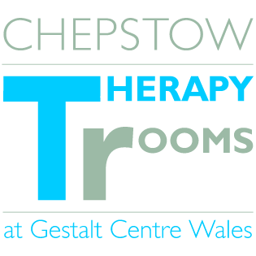 **Assertiveness Six week Group**

with Melissa Steyn FdSc Counselling MBACP

These groups are intended for anyone interested in learning more about assertiveness. The aim of the sessions are to help participants gain a better understanding of assertiveness, how to successfully assert themselves and the effects of being unassertive has on an individual’s self-esteem.

Dates: Wednesdays 10-11.30am: September 24th October 1st 8th 15th 22nd & 29th

Venue: Gestalt Centre Wales, 10 Hocker Hill Street Chepstow

Cost: A small contribution is requested to go towards the Centre of which participants can determine.

Please contact Harvene on 01291 622722 for further enquiries